**DAILY ONLINE ACTIVITIES SUMMARY**

|  |  |  |  |  |  |  |  |
| --- | --- | --- | --- | --- | --- | --- | --- |
| **Date:** | | **8/6/2020** | | | | | |
| **Name of the Faculty** | | **REENA LOBO** | | | | | |
| **No. of Students Allotted for monitoring** | | | | | **19** | | |
| **Progress** | | | | | **GOOD** | | |
| **Whether collected report from all the allotted students** | | | | | **18,not submitted-ramitha** | | |
| **Online Test Summary** | | | | | | | |
| **Subject** |  | | | | | | |
| **Semester** |  | | | **Duration** | |  | |
| **No. of students Taken** | | |  | **Passing %** | |  | |
| **Certification Course Summary** | | | | | | | |
| **Course** | | 1. ATTENDED WEBINAR ON INTRODUCTION TO DEEP LEARNING AND ALGORITHMS Certification provider:NITTDuration:2hr **2.** Completed final exam of python for data science course.  **3.** ATTENDED WEBINAR ON GESTURE RECOGNITION SYSTEM  DURATION:1hr  CERTIFICATION PROVIDER:PANTECH SOLUTION 4.Attended quiz on python programming | | | | | |
| **Certificate Provider** | |  | | | **Duration** | |  |
| **Coding Challenges** | | | | | | | |
| |  | | --- | | **Problem statement.** **Java program to delete a node from the middle of the singly linked list**  **.Language used for solving: JAVA**  **Whether posted in Github: YES**  **Link:** <https://github.com/orgs/alvas-education-foundation/teams/3rd-year/discussions/67>  **How many students attempted :31** | | | | | | | | |
| **Status: COMPLETED** | | | | | | | |
| **Uploaded the report in Github** | | | | | **yes** | | |
| **If yes Repository name** | | | | | <https://github.com/reenalobo/ONLINE-ACTIVITY-REPORT/upload/master> | | |
| **Uploaded the report in slack** | | | | | **yes** | | |

Certification Course Details: (Attach the snapshot and briefly write the report for the same)

**.** CODING CHALLENGE:

Java program to delete a node from the middle of the singly linked list

<https://github.com/orgs/alvas-education-foundation/teams/3rd-year/discussions/67>

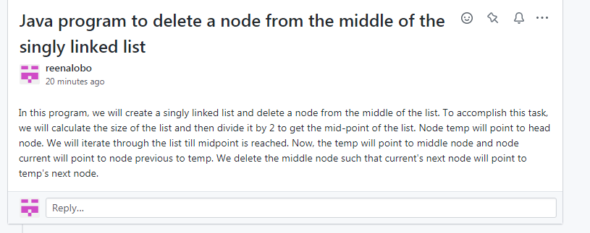WEBINAR ON INTRODUCTION TO DEEP LEARNING AND ALGORITHMS

NITT

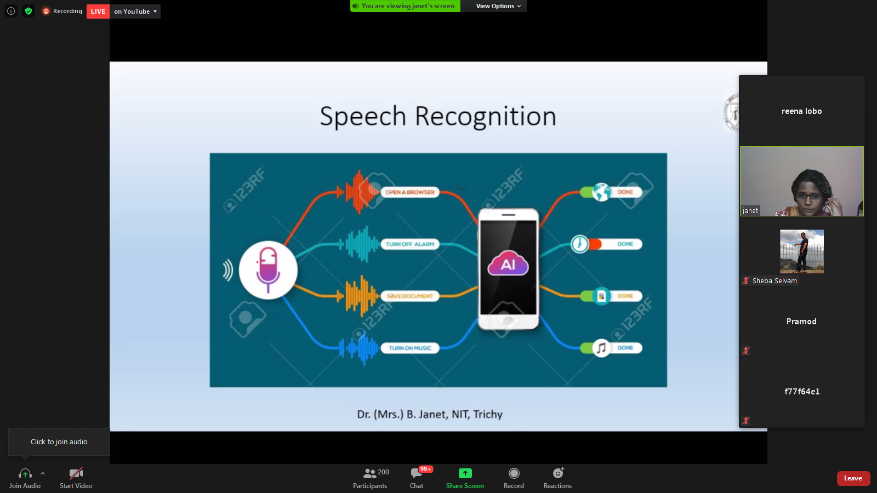

Completed final exam of python for data science course.

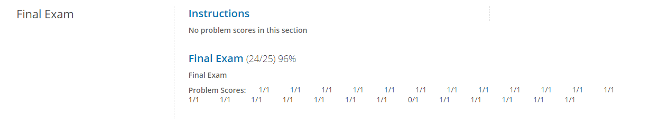

WEBINAR ON GESTURE RECOGNITION SYSTEM

PANTECH SOLUTION

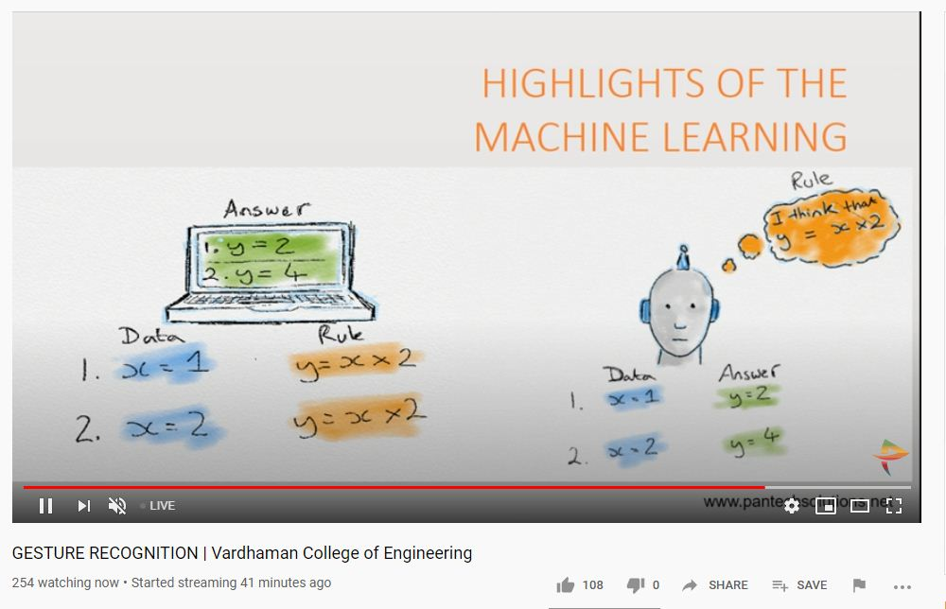

**Students report:**

**Ravali:**

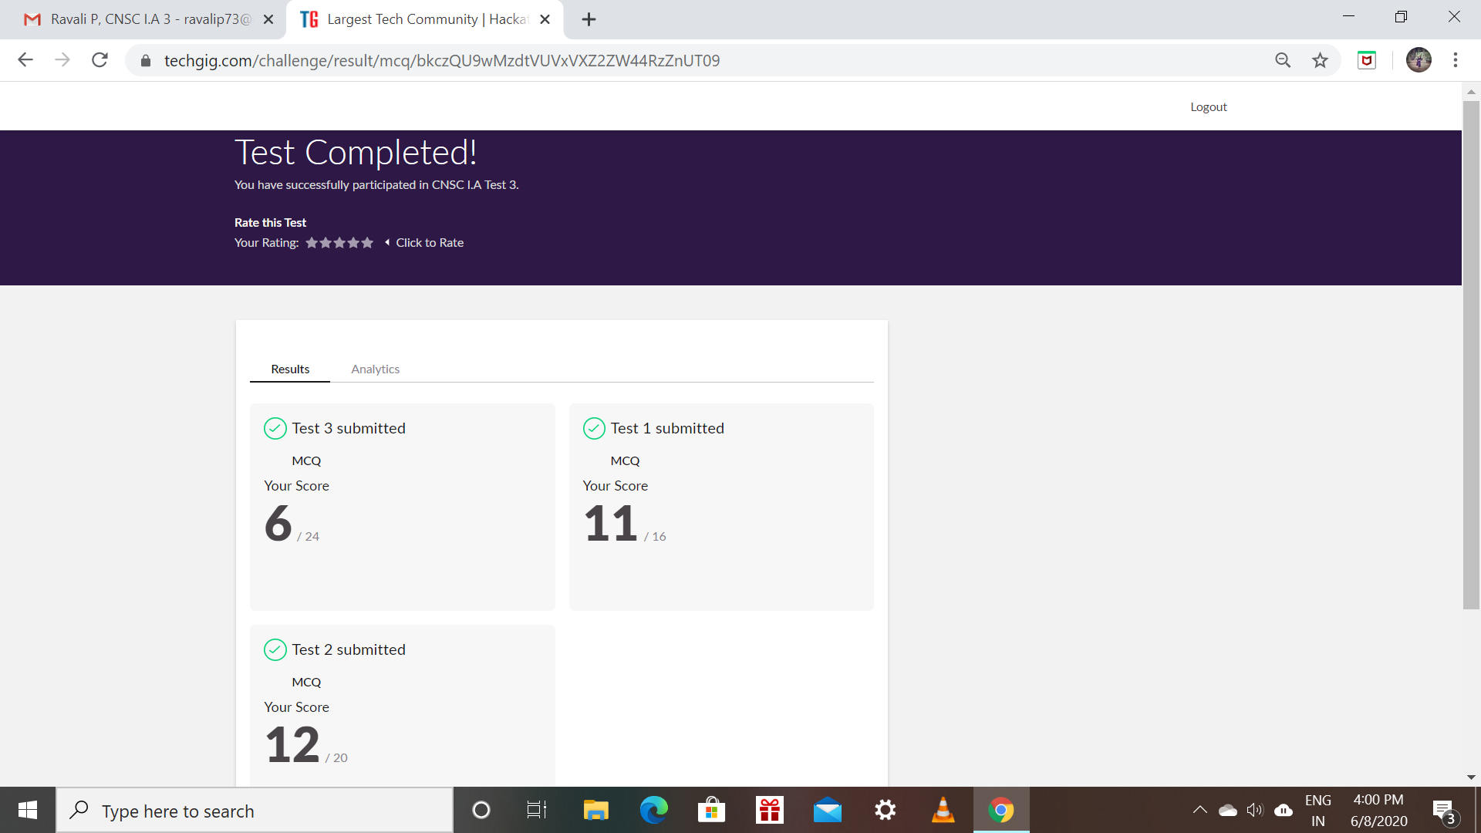

Certification Course Details: (Attach the snapshot and briefly write the report for the same)

* Completed the website development (HTML,CSS),learning course

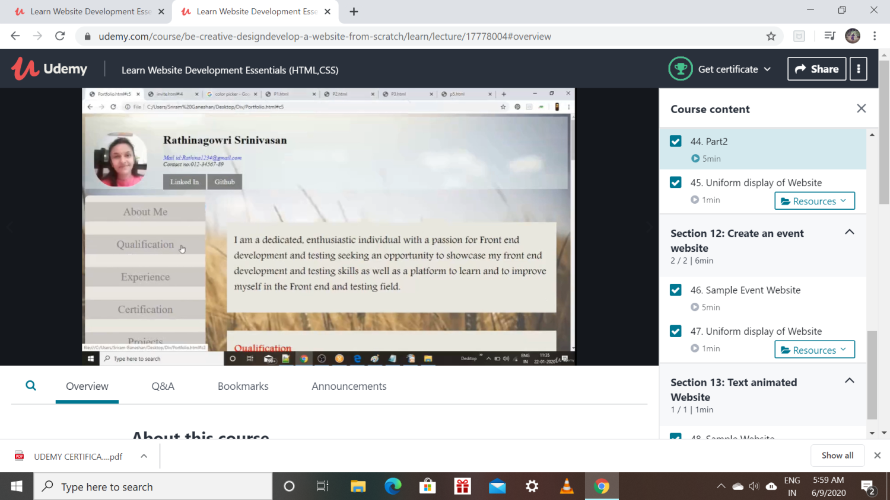

RAKSHA:

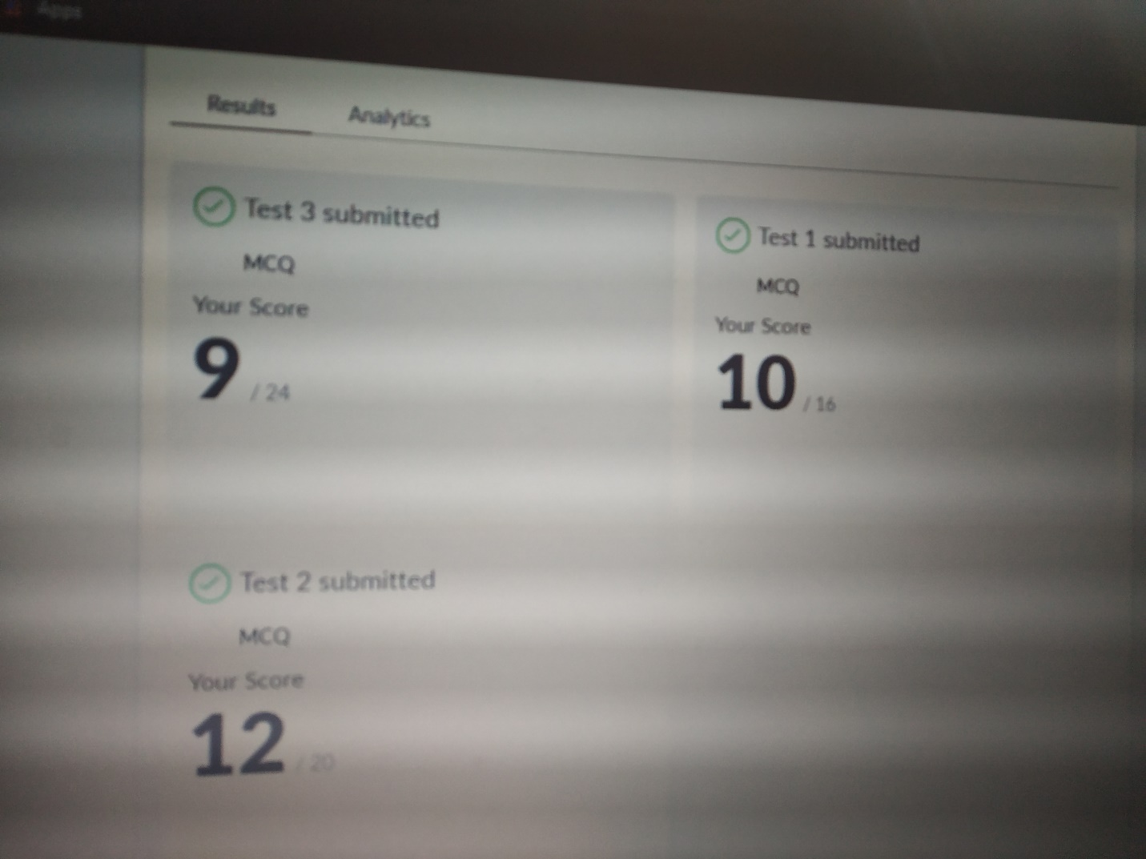

Scored 31 out of 60 in CNSC Test

Certification Course Details:

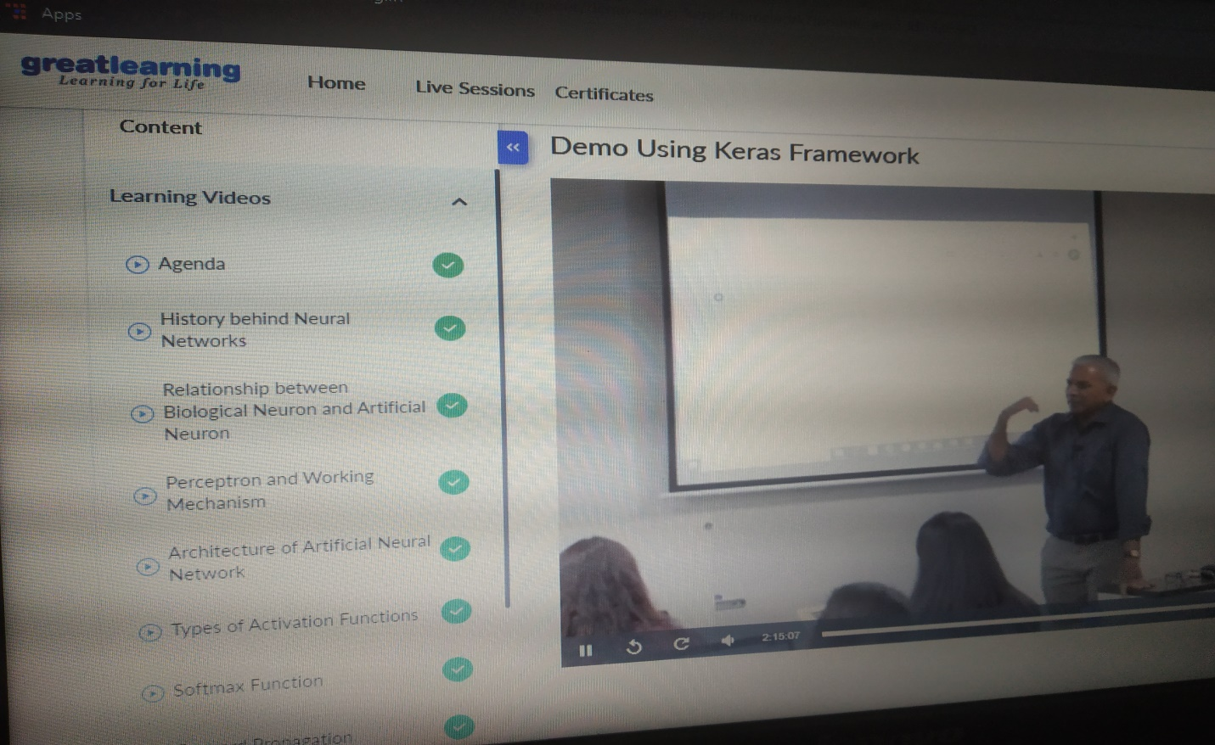

ROHAN MAHAVEER:

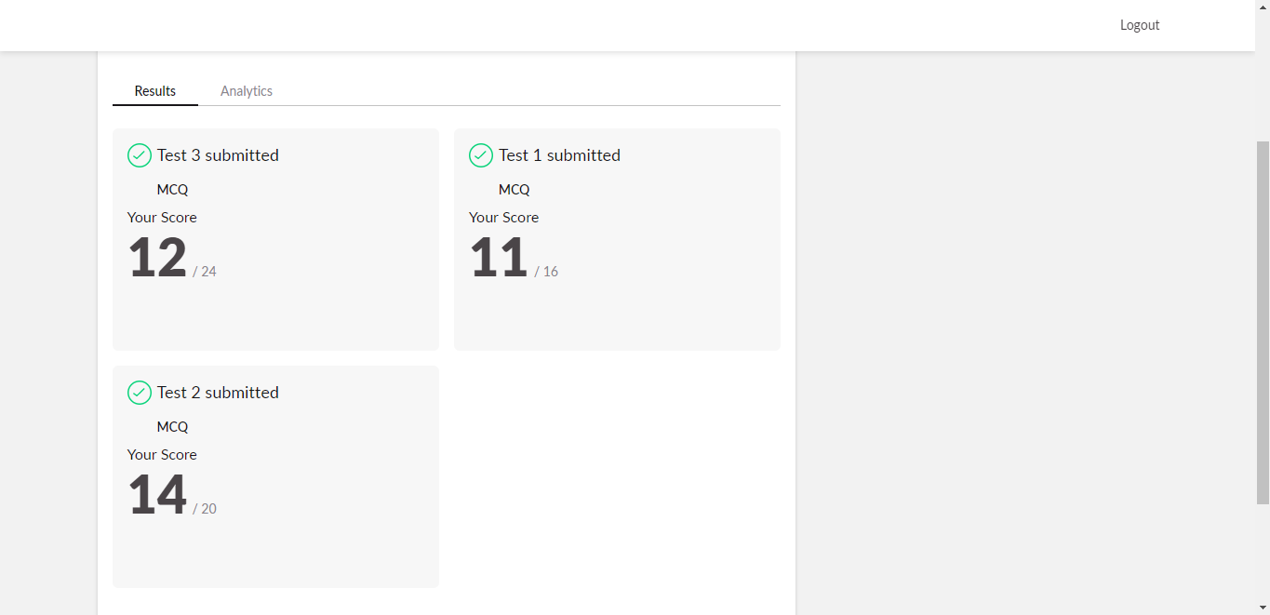

Scored 37 out of 60 in CNSC Test

Certification Course Details:

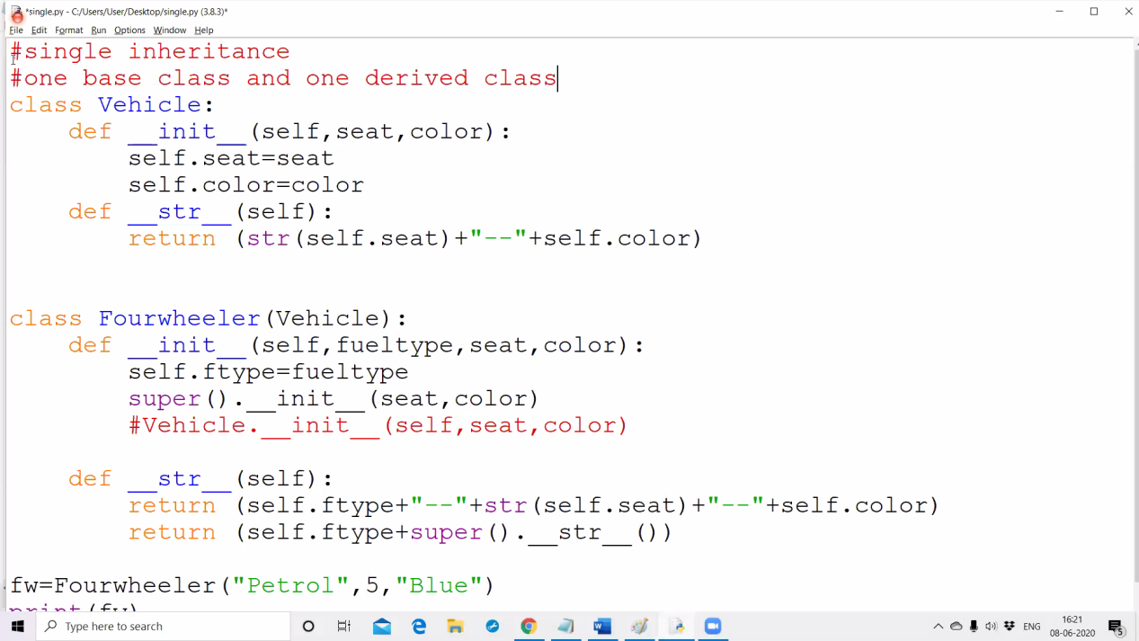

PREETHI:

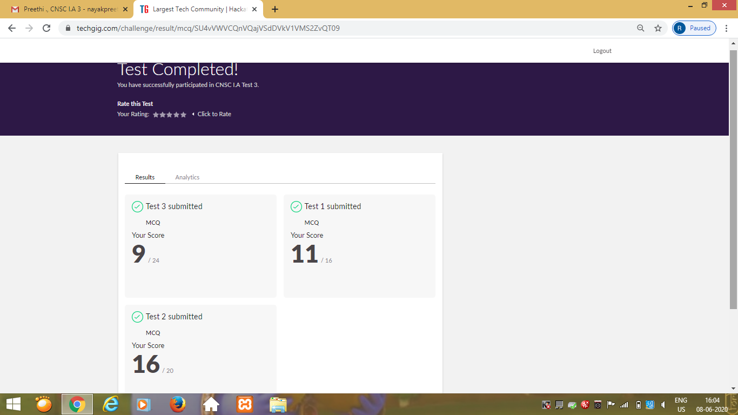

Certification Course Details: (Attach the snapshot and briefly write the report for the same)

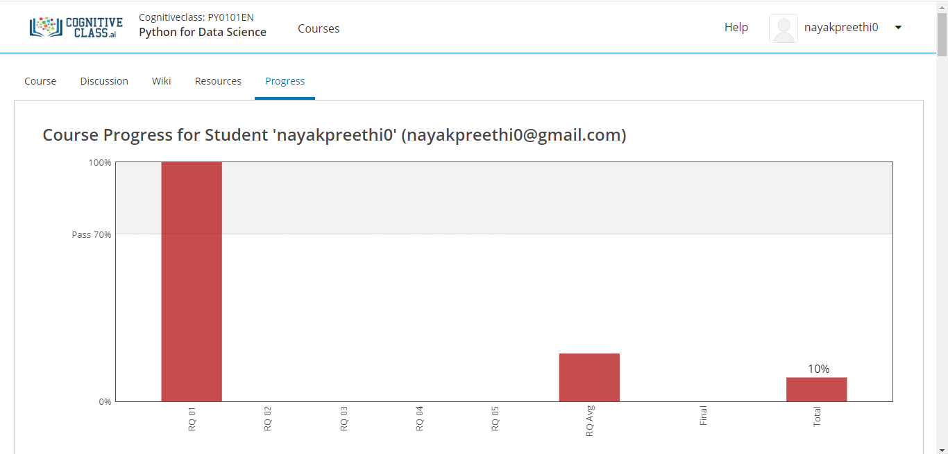

PRANAV:

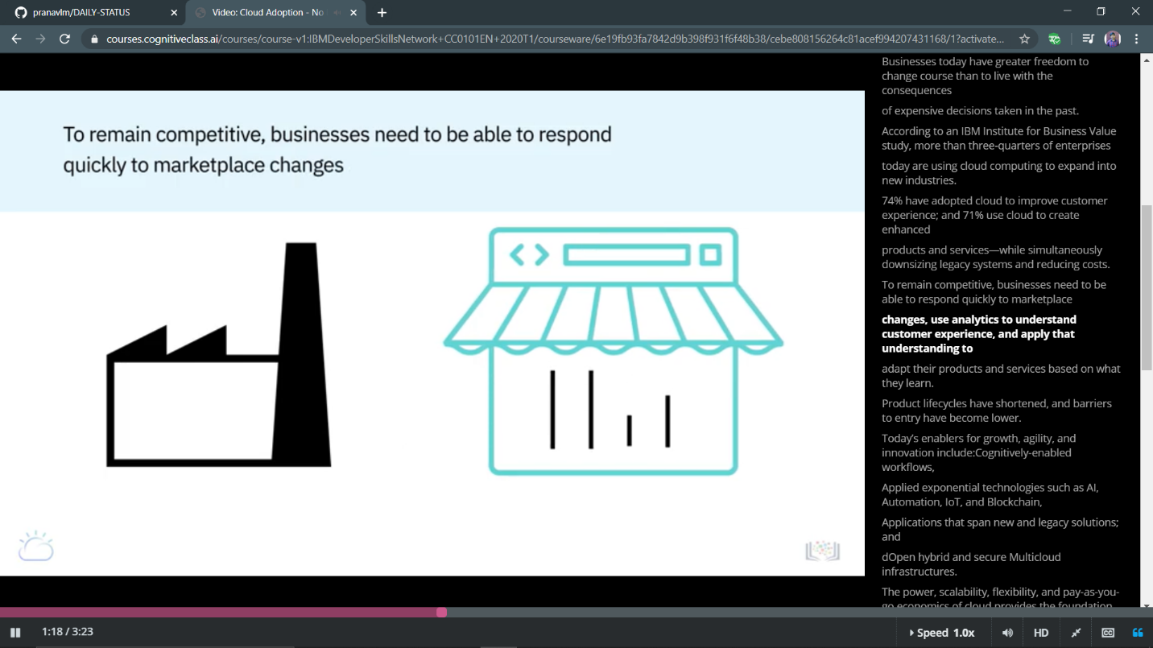

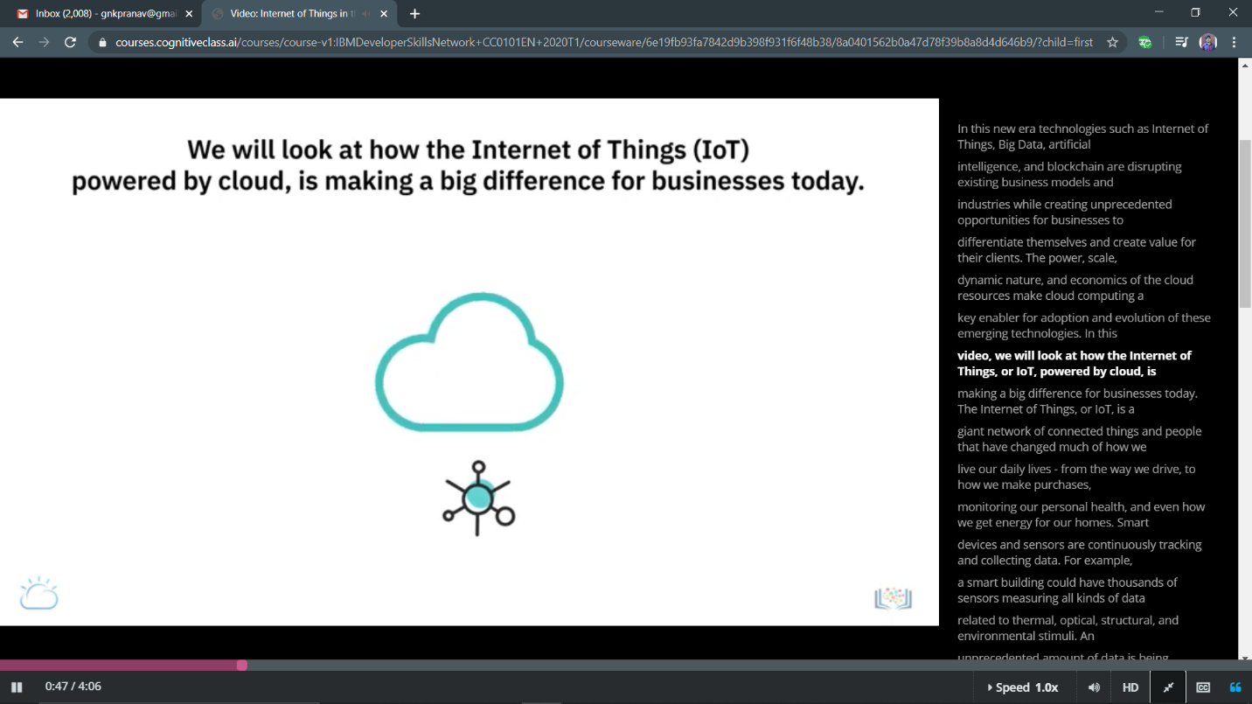

RANI:

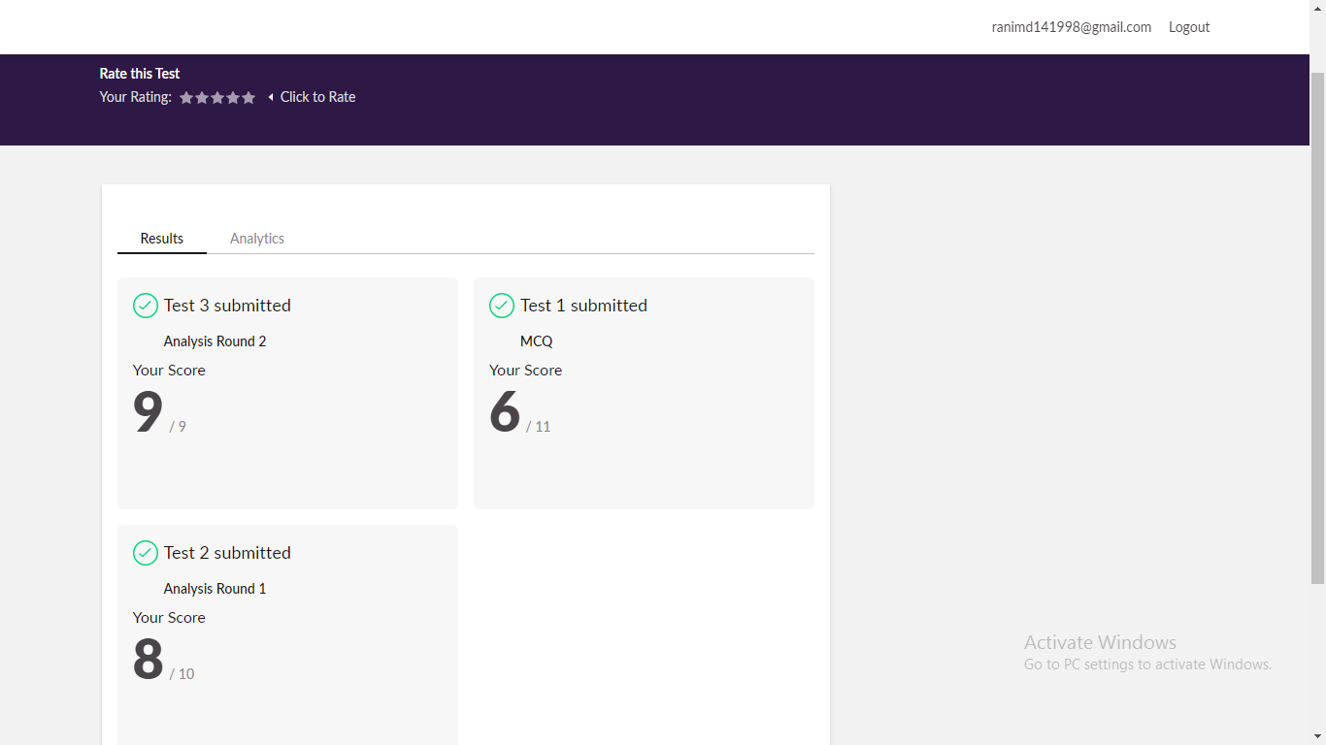CERTIFICATION COURSE:

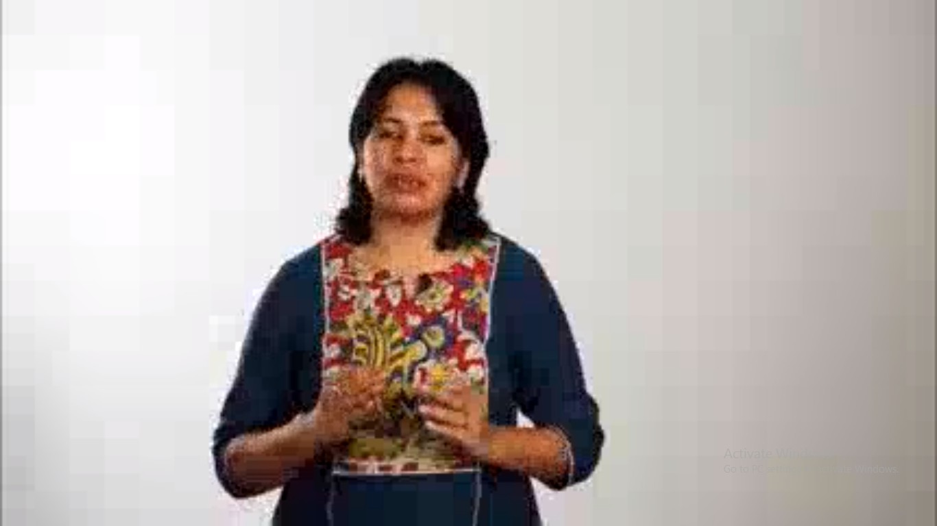

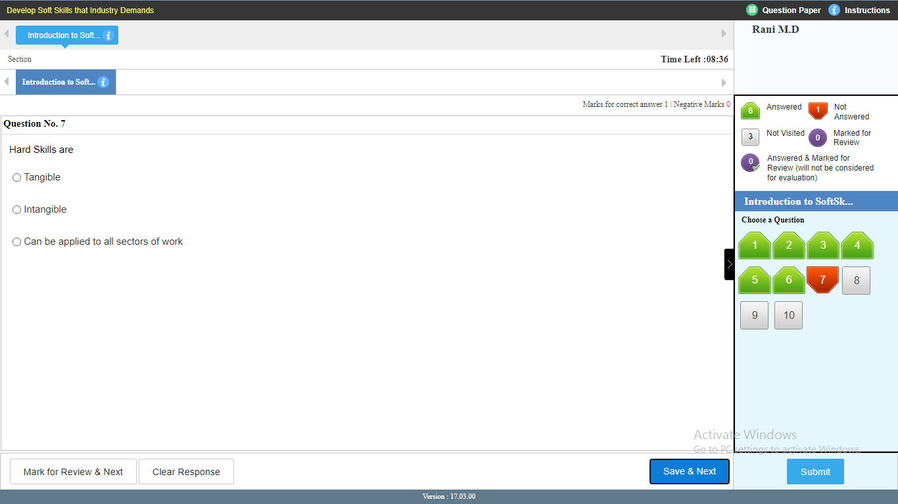

RACHANA:

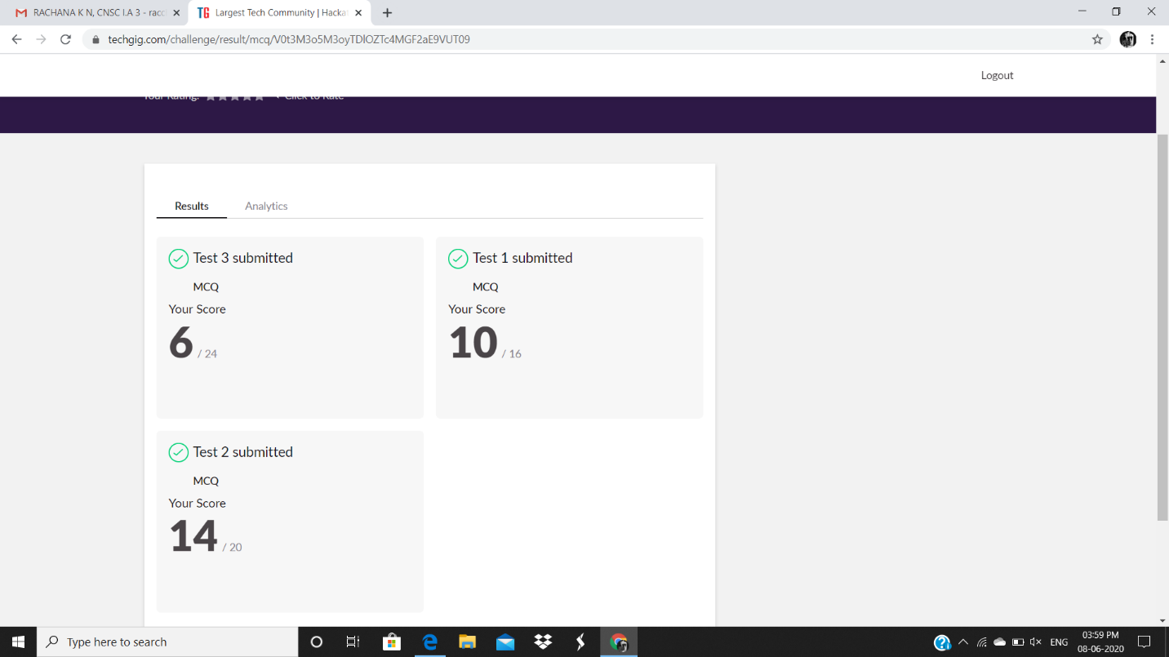

**Certification Course Details:**

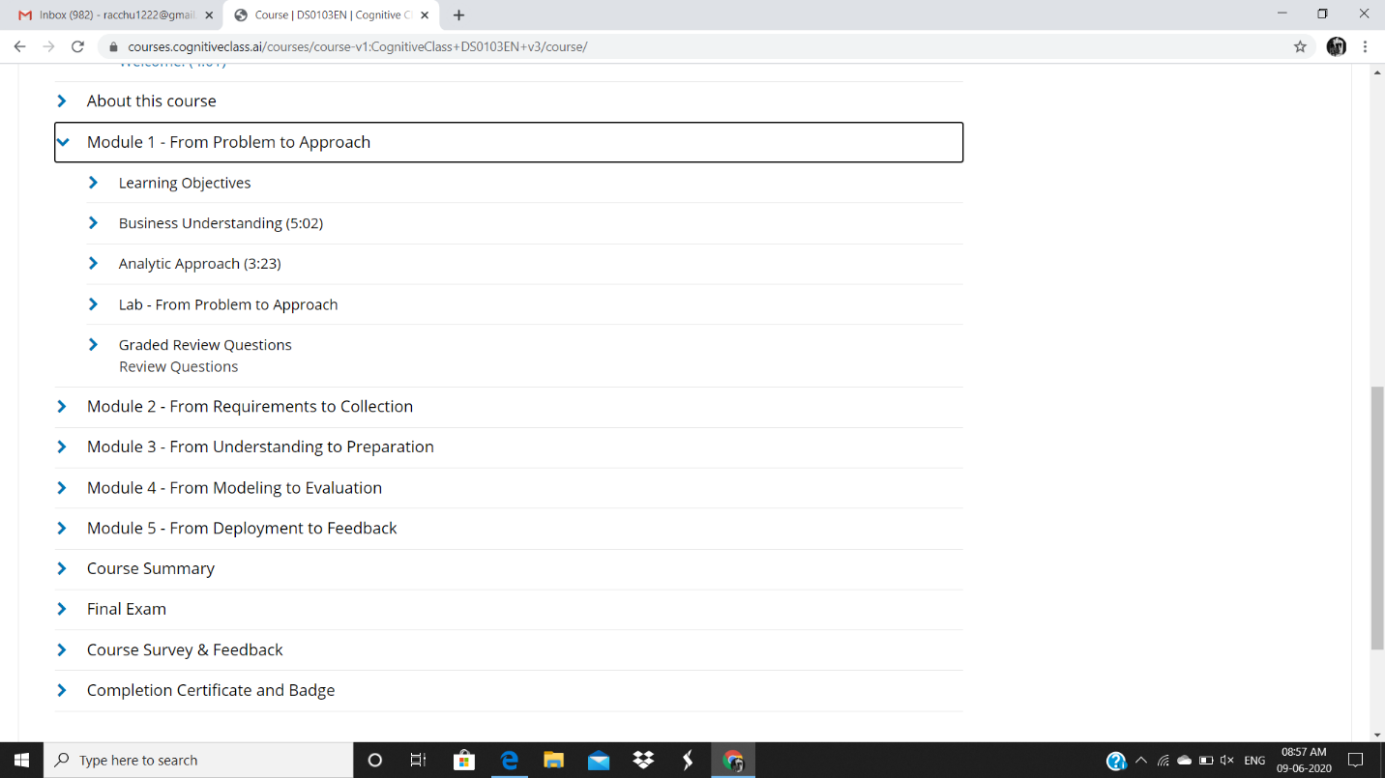

PRIYANKA :

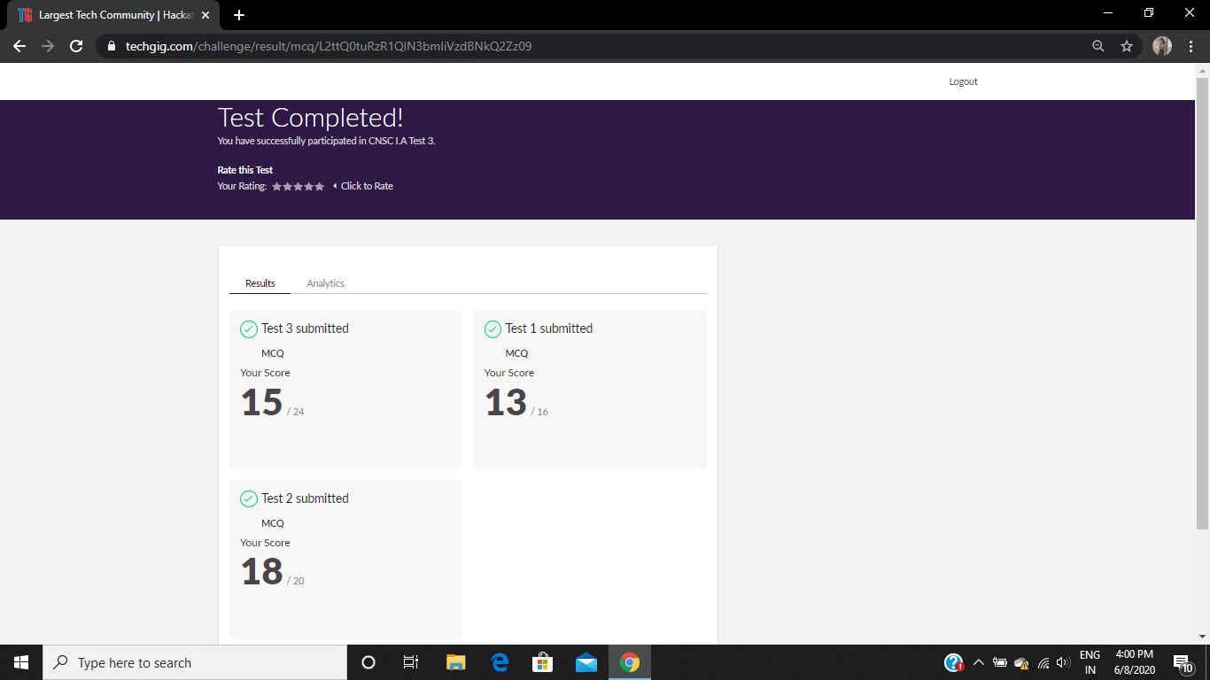

**Certification Course Details:**

**E-Box Classes:**

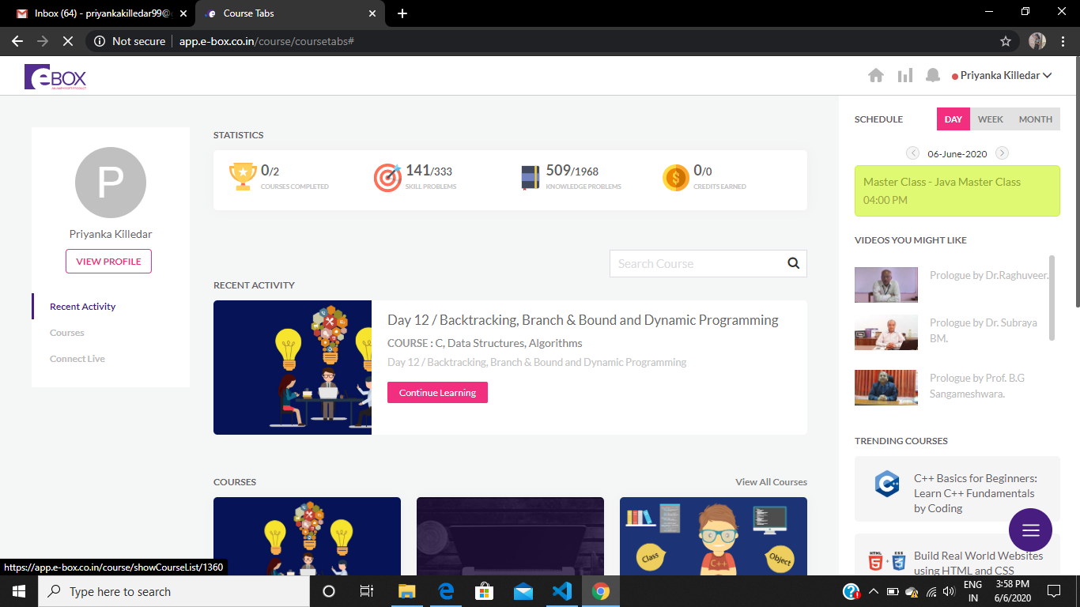

SANA:

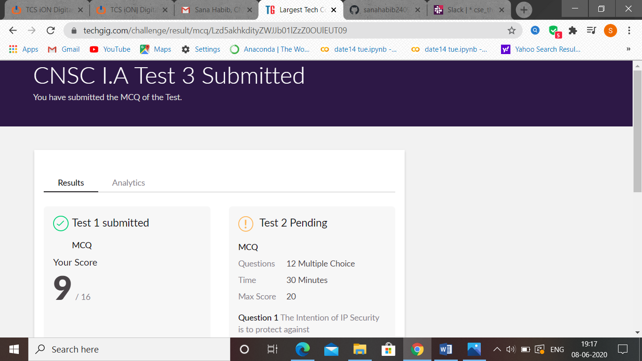

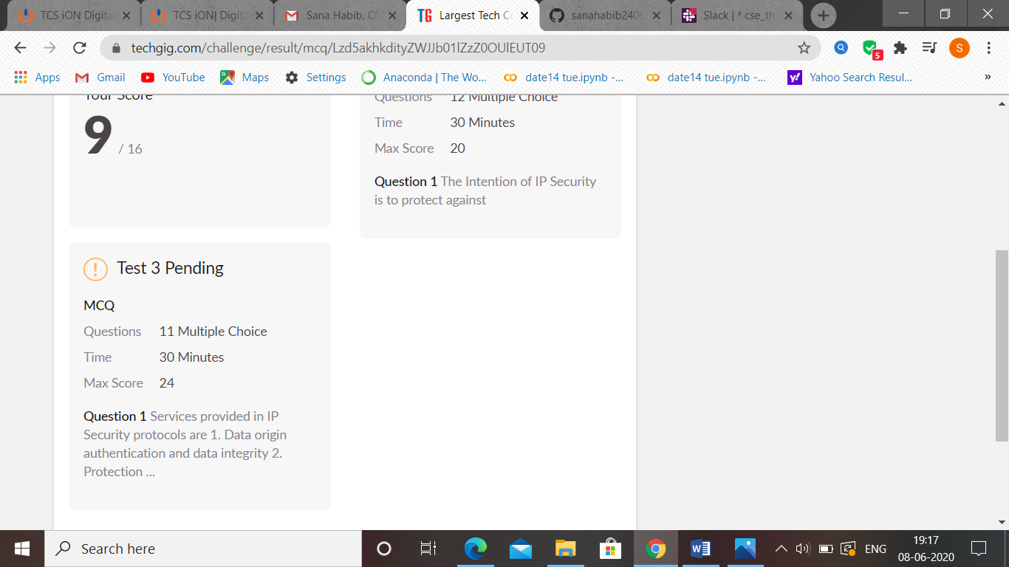

ATISH:

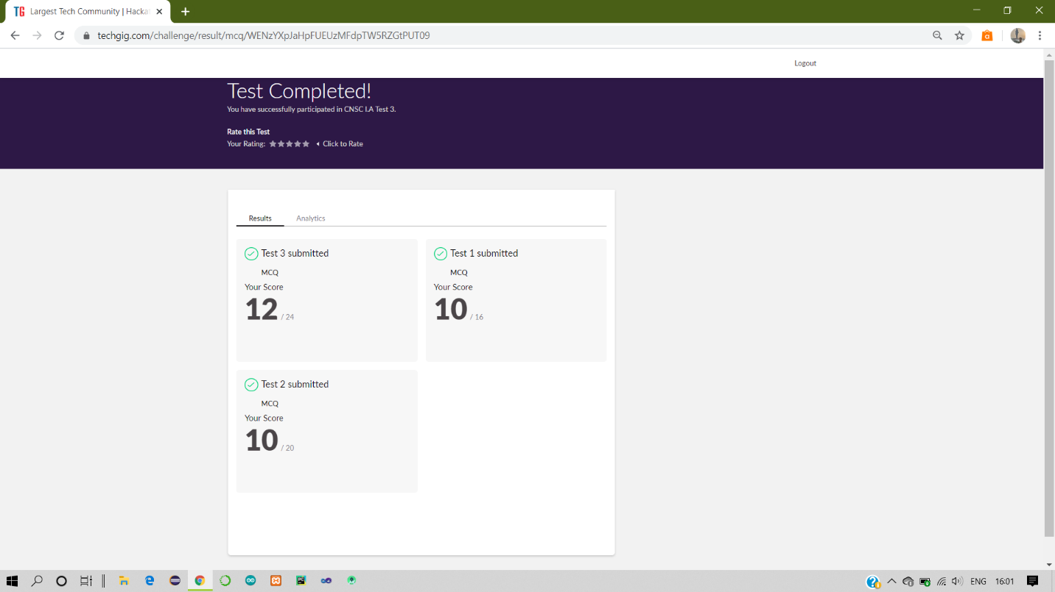

Certification Course Details:

Report-Solved knapsack assignment in programming and gained certificate

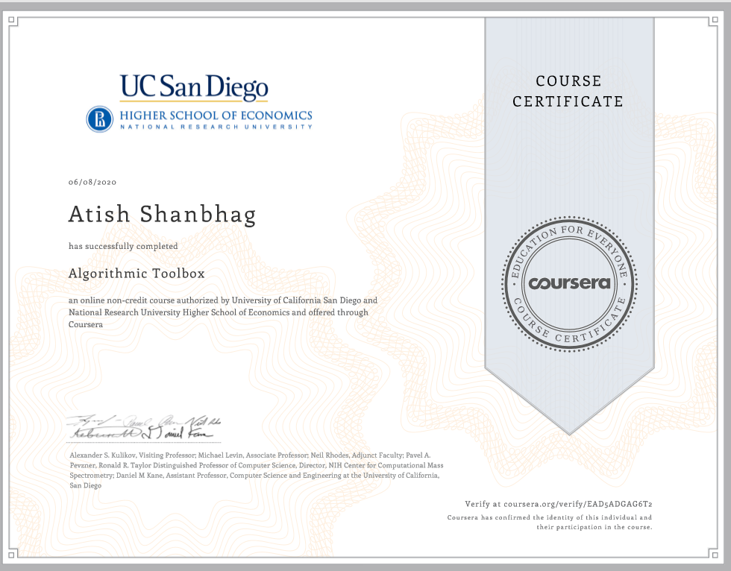

SHAH DRHUVIL:

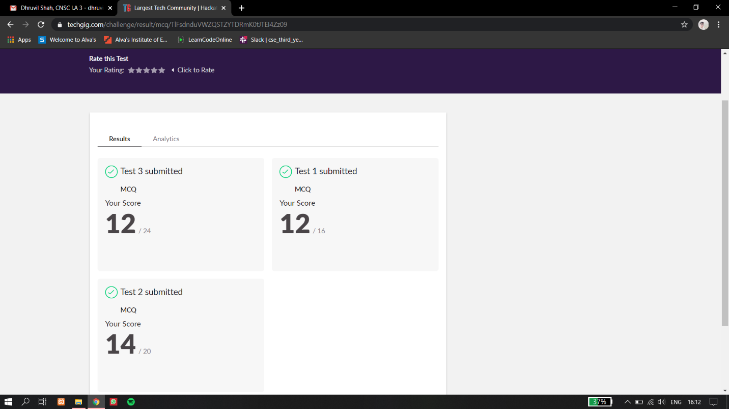

Certification Course Details:

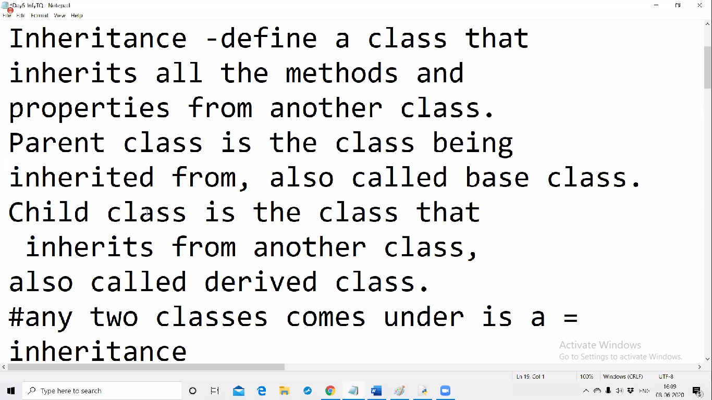

PRIYA H T

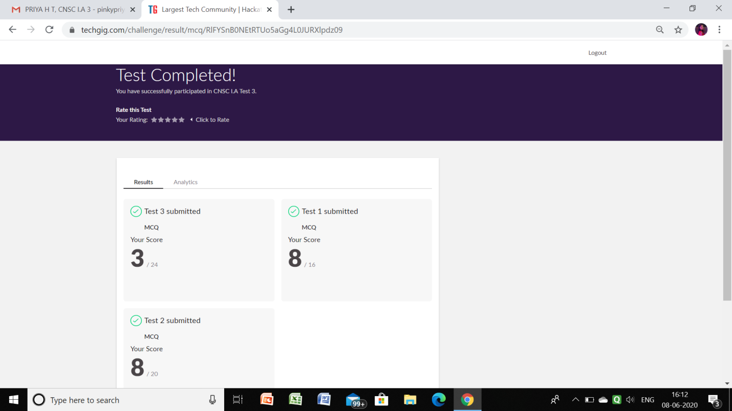

PRAVEEN KUMAR:

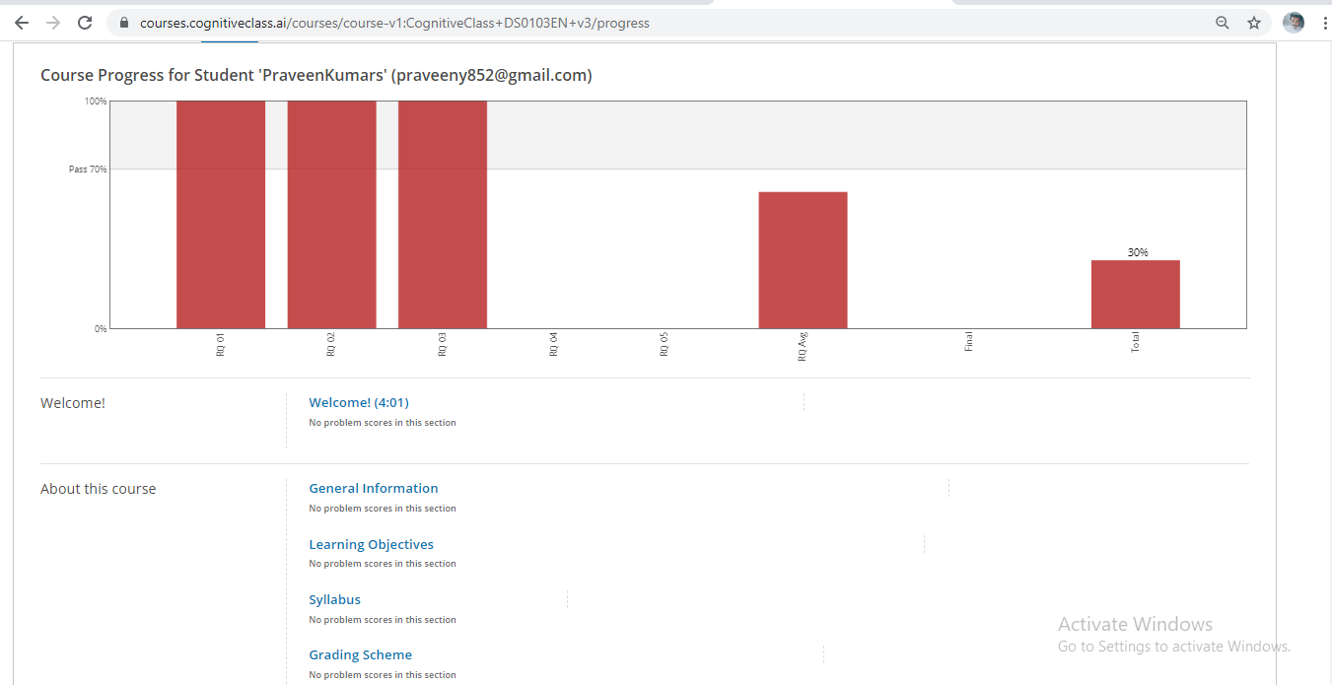

program snap

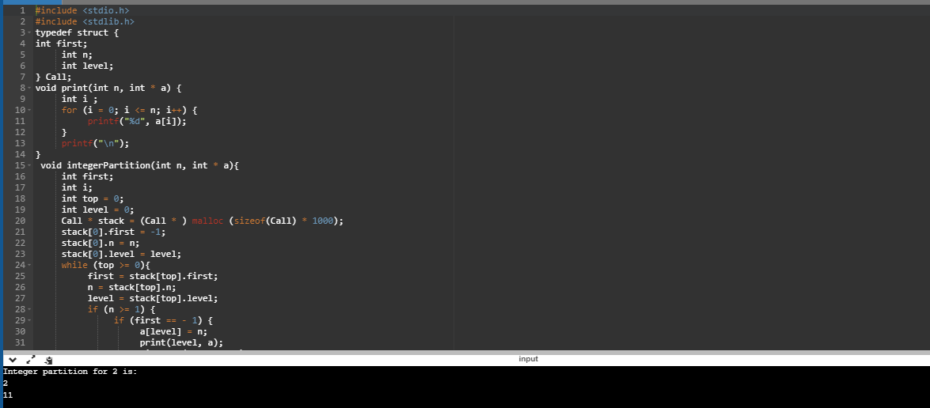

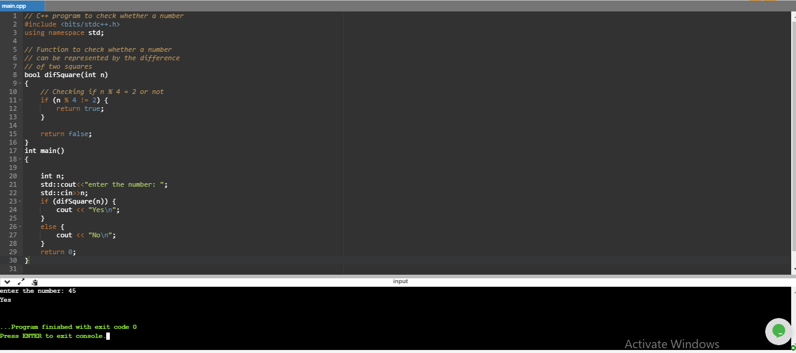

SACHIN:

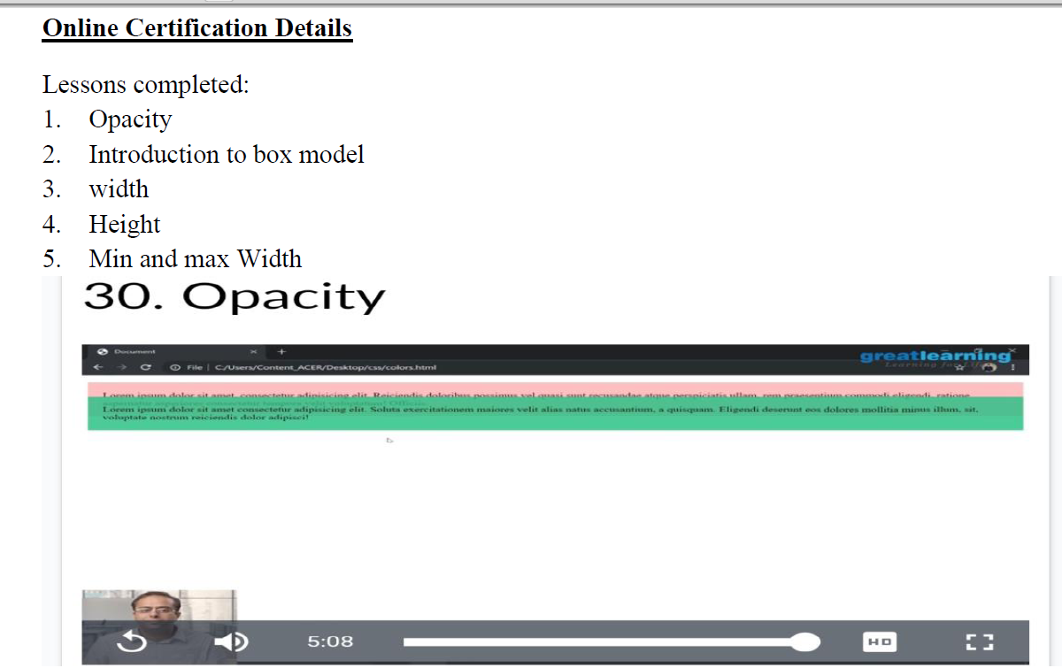

RAGHAVI:

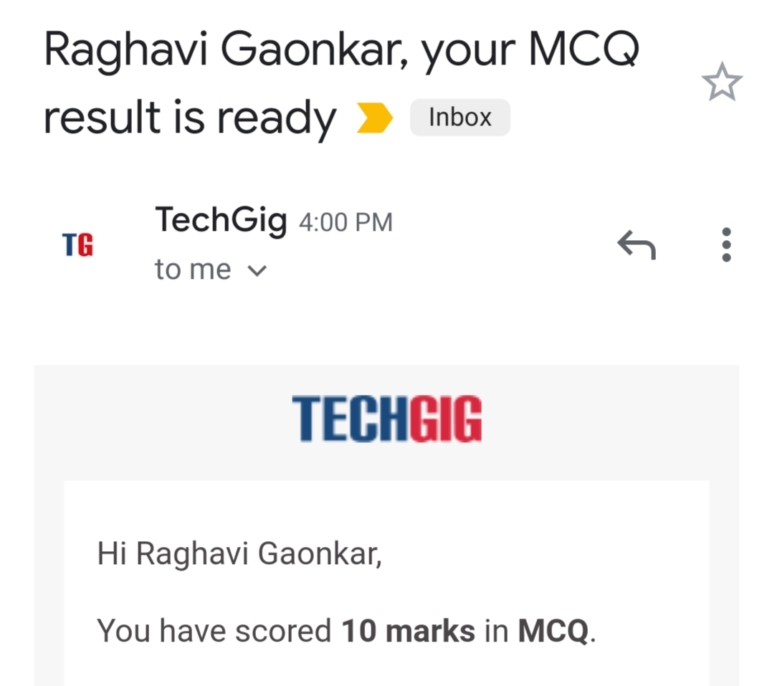

ROUSHA:

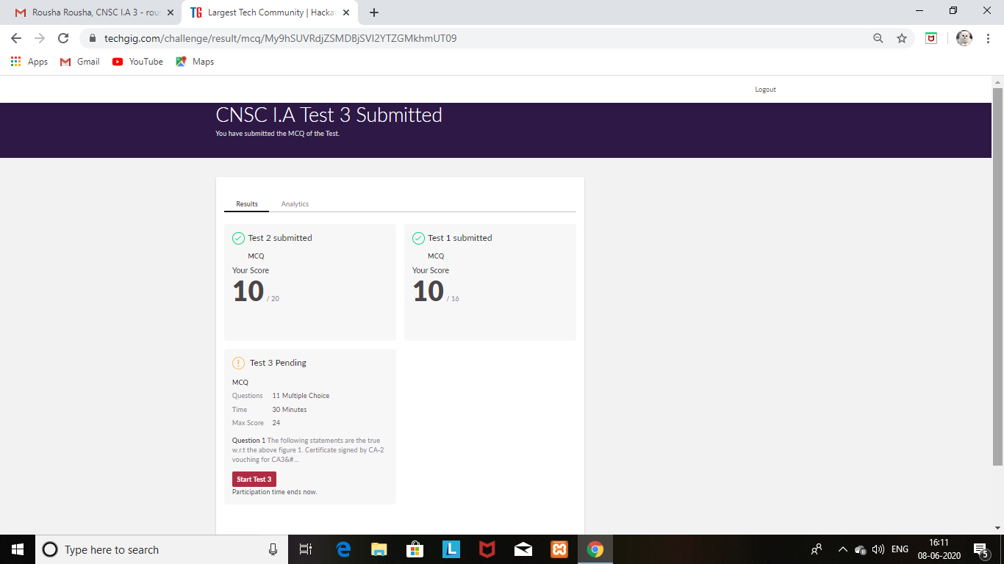

Certification Course Details: (Attach the snapshot and briefly write the report for the same)

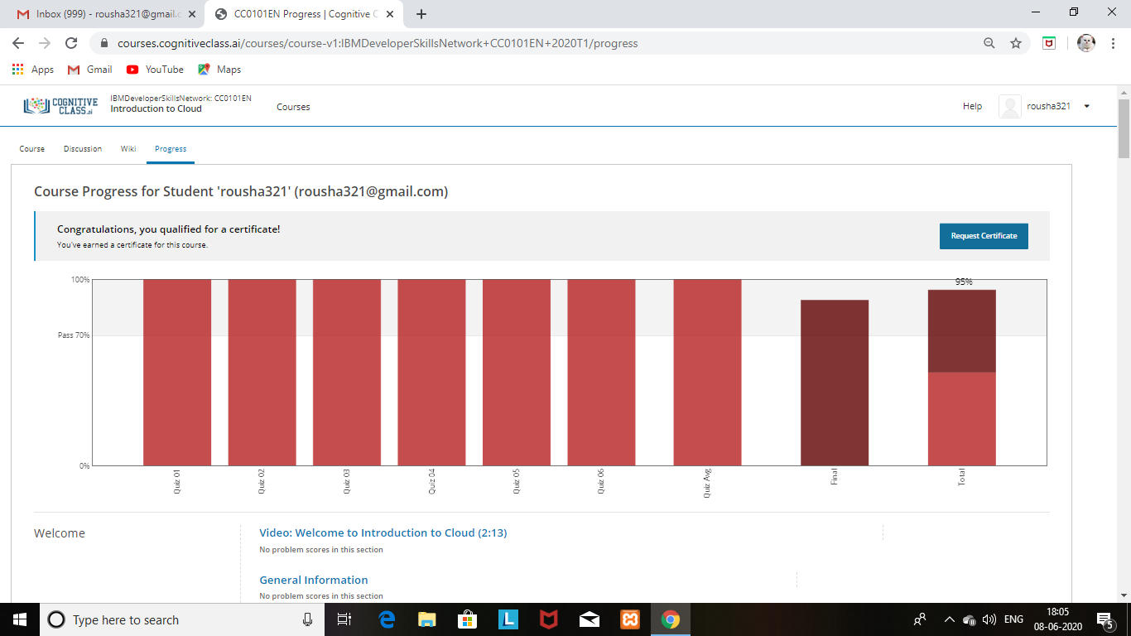

Completed the course and obtained a certificate and a badge for the same and uploaded it in Github

SHAIFA:

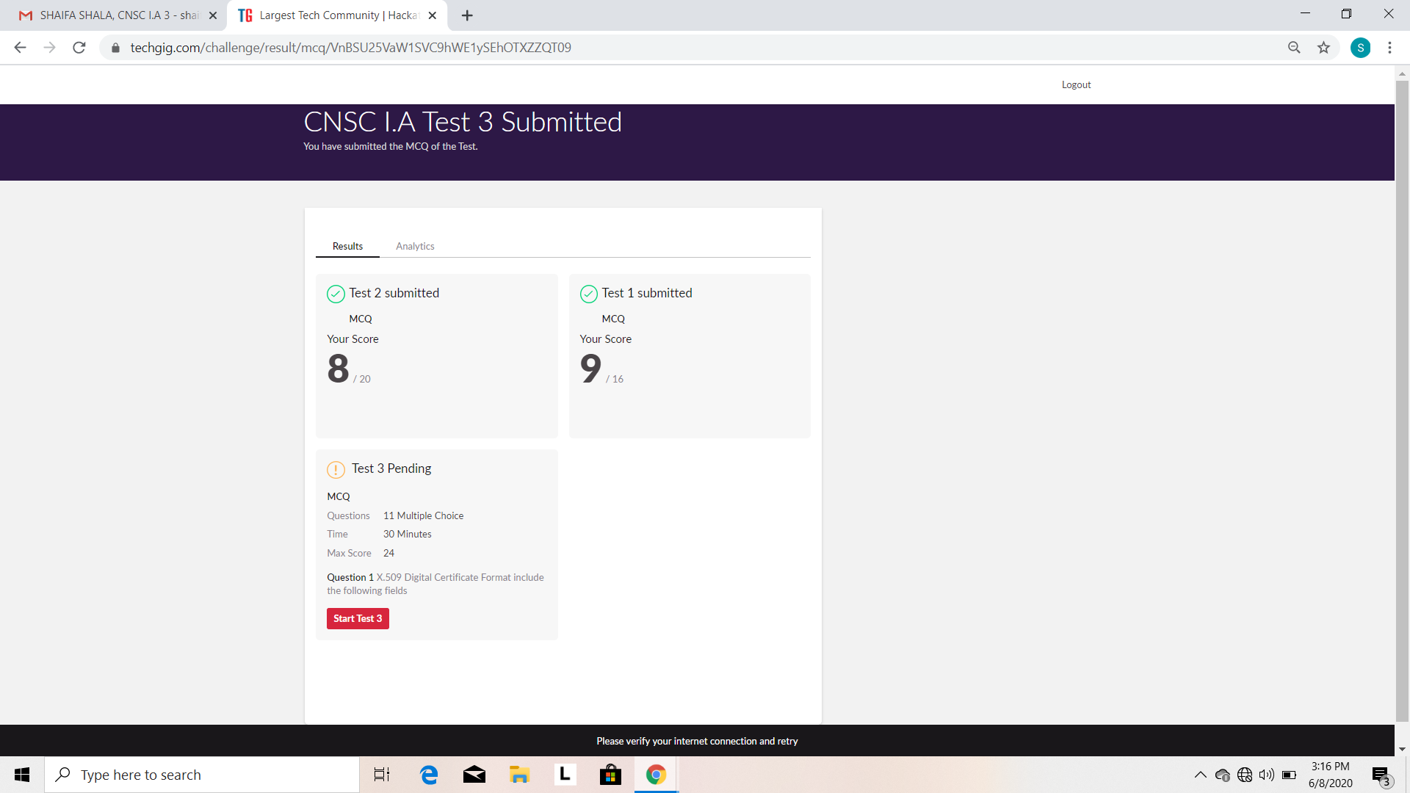

Certification Course Details: (Attach the snapshot and briefly write the report for the same)

